**Nguyen Thi Hoa**, 52, moved to Hanoi from a rural province of the North of Vietnam. She does several jobs at the same time. From very early in the morning, she sells eggs in a small market, then she comes back home to deliver egg to customers who call for her service. Right after that, she goes to a restaurant and becomes a waiter until the late afternoon. She is busy but happy because she feel safer about her life - “I am quite busy, but it is good, because I can earn more money to prepare for the time when I become older”.

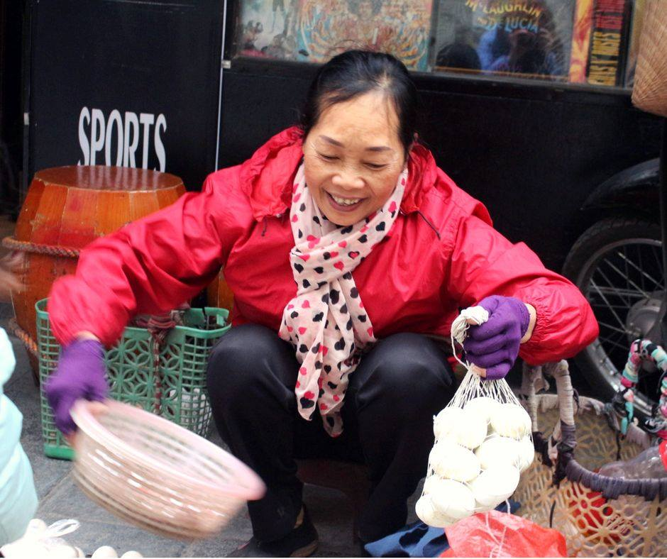Those positive signals of life don’t come to her just by luck. From 2016, she became a members of NEW ME! Project. Hoa and others have chance to discuss with each other about the basic skills and experience to start a small business, and more important, to maintain it. Hoa started to think about recording her expense to save money. She also advertises her delivery service through the information card, and try to connect to more restaurants which can use her service. More important, she got the loans from VSLA to invest to her small egg shop. Therefore, she not only can save the money better, but also maintains a better small business in a big city. She is happy to share her own experience and relations for working in the city to other members. That is really helpful for everyone.

“I am much more confident. That is not just because my income is increased, but also because I realize that a lot of people need me and respect what I can do for the community”.

CARE and our partner LIGHT have been making a lot of effort to support these women with economic knowledge and skills. From this, Hoa and other participants are becoming stronger and more confident migrant women in Hanoi city.